Title Times New Roman, Bold-face, 14-point font and Center

Author Name(s): First, Middle, Family name^{1*} Times New Roman, 10.5-point font and center
¹Department Affiliation, School or Company Affiliation
City, State Times New Roman, 10.5-point font and center
* E-mail: Corresponding author’s E-mail address

INTRODUctioN HEADING in capital and in bold face font.
The deadline for the submission of extended abstracts is 26th July 2024 (10.5-point font).
The requirements for the written abstract are the same whether it was accepted for an oral presentation or poster. All extended abstracts will be included equally in the conference proceedings, and will be published online.

REQUIREMENTS (10.5-point font)

Length (10.5-point font)
The extended abstract should be a maximum of four A4 pages in length.

Formatting
Files should be in MS Word format, based on this template file.
Fonts, heading styles, margins, etc. should be as in this template file (font Times New Roman, font size 10.5 point, except for title, 14 point bold).
Table and figure captions should be in italics, centred on the table (see Table 1) or figure (e.g. Fig. 1) with table captions above tables and figure captions below figures. Equation numbers (e.g. Eq. 1) should be in parentheses next to the right margin.
Table 1, table caption should be in italics, centred, placed above table
C1 | C2 | C3 | C4 | C5
10 | 20 | 30 | 40 | 50

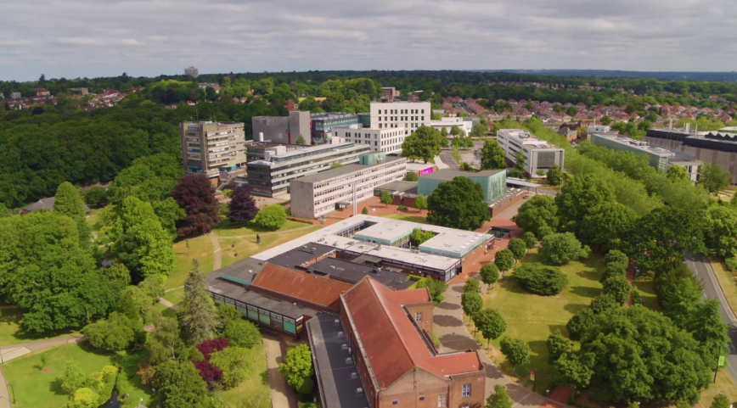
Figure 1, figure caption should be in italics, centred, placed below figure.

(1)

Authors must make sure that all details, such as figure labels, equations, variables, subscripts and superscripts are clearly legible when the document is printed on A4 paper.
References should cited by number, e.g. [1]. Examples are given below.

Submission
The file name should start with the allocated abstract number, followed by the corresponding author’s surname. The extended abstract (*.doc or *.docx) should be emailed to WES2024@soton.ac.uk.

REFERENCES (10.5-POINT FONT)
- Matsumoto M., Yagi T., Liu Q., Oishi T. & Adachi Y. (2005). “Effects of axial flow and Karman vortex interference on dry-state galloping of inclined stay-cables”, Proc. 6th Int. Symp. Cable Dynamics, Charleston, South Carolina, U.S.A., 19-22 Sept., 247-254.
- Wilson E.L. & Ibrahimbegovic A. (1990). “Use of incompatible displacement modes for the calculation of element stiffnesses or stresses”, Finite Elem. Anal. Des. 31, 229-241.
- Zdravkovich M.M. (1997). Flow around circular cylinders Vol. 1: Fundamentals. Oxford University Press, Oxford.

